Hello area 14 members,
We recently had our SFAB Fall conference meeting November 30 and December 1. This is where the SFAC chairs, fishing societies and DFO meet in one room to discuss area reports, issues and this year work on our new SFAB process. These meetings are usually hosted and funded by DFO to be held in person in Vancouver. But, a week or so before the scheduled meeting we were told the funding was pulled back by DFO and we would be bumped to an online format for this meeting. Although many of us are getting used to the online format, this meeting is very important to be held in person. It is just not the same as meeting face to face to talk about area issues, partnerships and those important out of meeting conversations. Below I will highlight some of the topics we covered and how we got represented. Overall, our reception for area 14 was well received and I personally made some key connections (would have been way better in person) that will help shape our advocacy plan.
Also, in the works I have talked with the Komox First Nation and have set up a meeting with the new Chief and council in the new year. I have been asked to give a 30min presentation then be open to question period. I hope to have a good conversation, show some key data, talk about our issues, hear their concerns, and see how we can get on a path to having their support in providing for fishing opportunities in area 14.
Agenda and conversation notes:
- The meeting started with each area introductions, brief overview of flagged concerns and reports.
“Some of Area 14s main Chinook concerns are:
- That I believe Area 14 is the only South Coast area other than 28 and 29 in Vancouver that has no Chinook retention opportunities during April – July 14th.
- We have 2 large Hatcheries in our area and our DNA stock Composition shows an abundance of unmarked hatchery origin fish caught in area 14. During the last 4 years out of 49 hundred and 10 samples we have not encountered a Fraser stock of Concern during September to May. Our findings also highlight a difference in stock composition between the Eastern and Western portions of the Strait.
- We would like to work with DFO to find some Chinook retention opportunities for April and May.
Some of our Coho Concerns are:
- That the majority of the streams in Area 14 have some form of enhancement. We have 2 major hatchery facilities enhancing coho. Both have had ESSR sales which allow for the sale of both marked and unmarked Coho. The Coho fishery in Area 14 and most South Coast areas are limited by our impact on Interior Fraser Coho. The restrictions only allow for retention of 2 marked Coho during most of the year. We would like to work with DFO to find fishing opportunities to allow for 1 unmarked Coho per day in portions of Area 14 from August 15th to December 31.
Some additional concerns we have are:
- That yellow eye rock fish are becoming commonly encountered over all depths and areas within area 14. Area 14 has limits of only 1 rockfish in general with non retention of Yelloweye. We would like to work with the department to move back to 1 rockfish or Yelloweye to reduce the overall mortality of released and retained rockfish.
- Lastly
- Area 14 is concerned over the mid water trawl bycatch of Chinook in Area 14. “

- Salmon Management – Mike Hawkshaw
• Salmon IFMP development
• Role of the IHPC
• MM/MSF update
We had a presentation from DFO on the above topics, below are some notes that concern area 14.
- The department isn’t entertaining any further MSF proposals for the 2024/25 fishing season.
- The MSF framework isn’t complete yet.
- Marking the status quo amount of fish.

Steve commented:

As the majority of fish in the Northern Strait of Georgia are from healthy stocks of unmarked hatchery origin. We should start to use our data to decide where these mass marking trailers should be used to best benefit the most users. Such as marking more ECVI and Chilliwack fish.

George Bates followed with a motion for area 14 from the BCLCA:
Whereas Marked Selective Fisheries are being considered and under review and
Whereas DFO has purchased marking trailers that allow for large numbers of fry/smolt marking and
Whereas several hatcheries have surplus sale “ESSR” fisheries
Therefore be it resolved that DFO proceed with mass marking of the Chinook production from the 2023 brood from those hatcheries that have had surplus sale “ESSR” fisheries.
Moved George Bates

- The remainder of day 1 was followed by formality discussion on the new operating terms for the SFAB and a report on the proposed marine conservation objectives.
- Day 2 started with elections of positions within the various committees, executive roles and working groups of the SFAB.
Steve volunteered to be a part of the Salmon committee.
If you would like to be more involved. There are many working groups that are looking for your input. These are groups you do not need to be a seated SFAB member to work with. This would involve you having your input on emails or possible virtual meetings whenever your available. I.E Salmon, Bottom fish, and pelagic including Prawn, Crab, Herring Tuna etc.. Contact me for further details.
- We then discussed flagged motions. Below are the 2 motions area 14 SFAC put forward.
Area 14 Chinook Motion (Nov-2023 Area 14 SFAC Chinook Motion)

Whereas all of Area 14 has no Chinook retention opportunities from April 1st to July 14th and

Whereas Area 14 contributes a significant amount of DNA samples, close to 14.5% (8081) of all samples year-round and 13% (397) during April and May are submitted by local Avid Anglers (see attached sheet) and the recent DNA analysis, (2019 to 2022) 4 years of samples from Area 14 have shown Zero stocks of concern being caught in the proposed open area (see attached map) and

Whereas current DNA samples show that during April and May the majority of the Chinook catch in Area 14 are from local hatcheries or US stocks. These stocks, on average make up 69% of the stock composition during this time frame (see attached sheet) and
Whereas blanket April 1st closure was brought in by DFO without considering the economic impacts. The complete non-retention and having no opportunity to catch and retain a Chinook has a negative economic impact on local tourism, charter boat business and local recreational anglers. The proposal provides a transition from 2 per day no max size September to March, to a limited precautionary approach during April - May and

Whereas because there is limited recreational fishing opportunity in Area 14 during April and May there is a limited opportunity to gather essential recreational fishing data; effort, CWT, information and ratios, catch and biological samples. DFO could consider this proposal as an assessment fishing opportunity to gather this essential data.

Therefore be it resolved that DFO provide recreational anglers in Area 14, in the described Western portions of PFMA 14-13 be allowed to retain one Chinook per day 62-80 cm in April 1st to May 31st and

Further be it resolved that as this opportunity represents a low risk and precautionary approach providing a local fishing opportunity in Area 14. That this proposal be assessed / reviewed under the Department’s Chinook Evaluation Framework and to be considered an assessment fishery for gathering effort, CWT, information and ratios, catch and biological samples on the stock composition and recreational fishing during this timeframe within the proposed area.

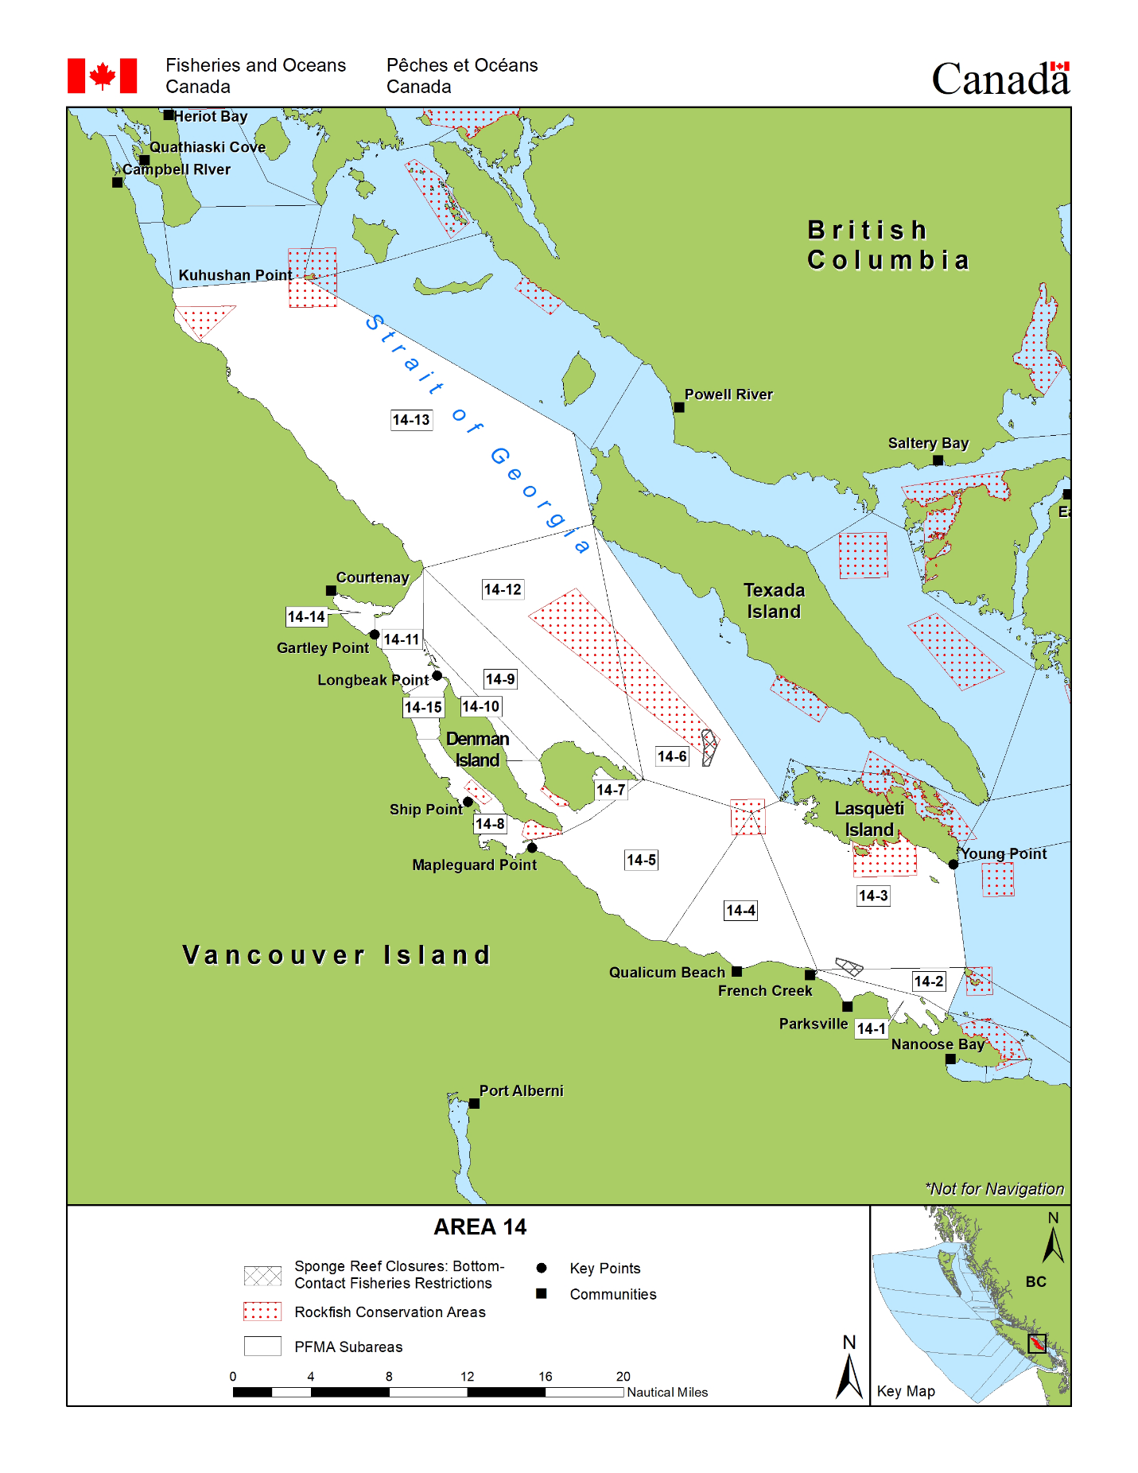
This map represents the approximate area we are proposing. The square green box is the reference point and are the approximate locations of the Lat and Longs posted below.

SW, Cape Lazo, 14-13 boundary junction 49’42.080, 124’51.564
SE, Cape Lazo, 14-13 boundary line 49’42.888, 124’46.842
NE, Mitlenatch SW RCA boundary junction, 49’55.488, 125’1.878
NW Kuhushan Light 49’53.305, 125’7.353

This picture also shows our proposed area with the current Puntledge Summer Run protection April – July 31 corridor represented in blue.

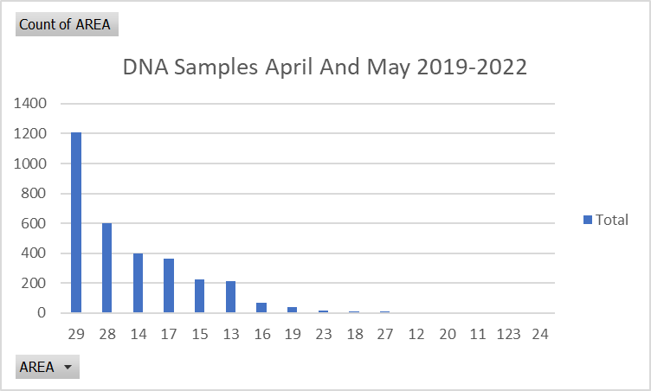
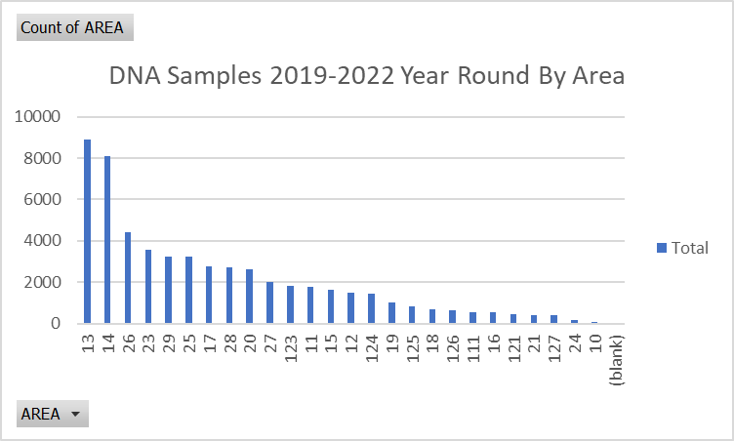
Area 14 April and May Stock Comp. 2019-2022
Stock | Percent
ECVI | 38.77%
U.S | 31%
Fraser Fall | 25.11%
Other | 5.12%

Coho Motion Area 14 November 4, 2023
Whereas In Area 14 the Puntledge River has significant returns of Coho above broodstock requirements. A significant number of the returns are marked.
Therefore Area 14 requests that sub-area 14-11 be open to 4 Coho per day one of which can be unmarked Aug 15th to Dec 31st and that the Puntledge River be open to 4 marked Coho per day.
Further be it resolved that DFO review the returns and adjust annually, as required.
Moved Nick Strussi
Second George Bates
Generally, the meeting went well. I made some good connections and area 14 was complemented on our efforts and representation of our concerns. I feel we will have to hang in there for the nest couple of years to start seeing the benefit of our efforts. I encourage everyone to stay positive and get involved when you can. I will keep everyone up to date on meetings and points of note. I welcome your engagement, its one small thing we can all do to help. If any of you are interested in getting involved in the volunteer data collection, SFAB volunteering or think you can provide your expertise in your experience to help shape our advocacy fight please contact me at any time. I am also always open to having phone calls or coffee to sit down and help you learn the ins and outs of what’s really going on and help understand. We must show how we, the people that enjoy the resource share the responsibility in helping the resource by being properly informed on topics to help move the needle in our direction.

Appreciate you reading my long email, Thanks!
Steve Veloso SFAC 14

